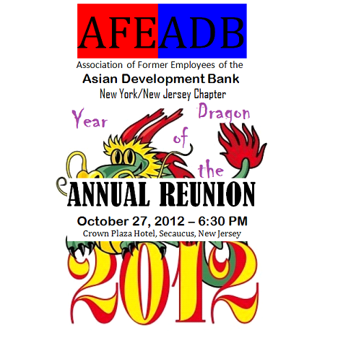
COST – US$65.00 per person

AFE-ADB NY/NJ CHAPTER
2012 COMMITTEE MEMBERS

OSCAR M. COLMENAR, Chairperson, ocolmenar@hotmail.com, Cell 201-290-1739
EMMA DUMALAG, Treasurer, dumalag@un.org, Office 212-963-2395
RUTH ESMILIO, Journal Publisher, ruth.esmilio@undp.org, Cell 845-642-8942 or 41

INVITATION COORDINATORS

CHAT CORTES cortes@un.org, Cell 914-433-0850
ANGEL CALILAP aacalilap@gmail.com, Cell 973-202-0392
ELENITA MIGNINI mignini@un.org, Cell 201-456-4566

PARTY RECEPTION COORDINATORS

CHOLLY MAURICIO chollym@gmail.com; PRECY M. ANDREWS, lilidahl@msn.com
or prImemuLtisvcs@yahoo.com, Home 718-472-5058, Cell 718-666-2971
TINA AQUINO, aquino1@un.org; MARGIE BACCAY, baccay@un.org

PROGRAM SET-UP COORDINATOR

NENA VILLENA-TANEDO villena-tanedo@un.org, H 718-478-8178
ANNIE ROMERO romeroanisa@hotmail.com
VIVIAN VILLANUEVA vivian.villanueva@wfp.org

For Direction: http://www.ichotelsgroup.com/crowneplaza/hotels/us/en/secaucus/nycmd/hoteldetail/directions

